Career Compass

Introduction
- Project Title: Intelligent Virtual Career Advisor
- Project Name: Career Compass
- Team Name: NeuroTech Haven
- Team Members:

- Patel Yug – Backend & Firebase Integration [Team Leader]

- Desai Khush – Frontend Developer

- Chauhan Vedant – AI Prompt Engineering

- Vishwesh Panchal – UI/UX Designer
- Date: 12-04-2024

Problem Statement
- Idea:

An AI-driven platform designed to guide individuals through their career paths by leveraging data on market trends, skills, and job opportunities. This tool assesses users' abilities, compares them with the current job market landscape, and offers personalized recommendations to help users optimize their resumes, prepare for interviews, and strategically network. The system aims to simplify and enhance career decision-making with actionable insights and tailored advice.
- Key Features:

1. Skills assessment

2. Job market analysis

3. Resume and interview tips

4. Personalized career path recommendations

5. Integrated network analysis

Proposed Solution
- Develop an AI-based platform that acts as a Virtual Career Advisor
- Guides users with personalized insights, recommendations, and resources
- Uses real-time data and AI models for decision-making support
- Helps users plan strategically for their career goals

Project Objectives
- To build a secure, responsive, and professional web platform
- To provide features like:

- Skills assessment

- Job market analysis

- Resume tips & interview prep

- Career recommendations

- Network analysis & suggestions

Technology Stack
- Frontend: HTML, CSS, JavaScript
- Styling: Bootstrap/CSS3
- Backend & Auth: Firebase Authentication
- Database: Firebase Firestore
- AI Integration: OpenAI GPT API
- Deployment: Firebase Hosting

User Access Flow
- Sign-in required before accessing any platform feature
- Firebase handles secure authentication
- All pages check user login status before loading content
- User redirected to Dashboard post-login

Platform Structure (Multi-Page Website)
- index.html – Login Page
- dashboard.html – Main Feature Hub
- skills.html – Skills Assessment
- job-market.html – Market Trends
- resume-tips.html – Resume & Interview Tips
- recommendations.html – Career Advice
- network.html – Networking Suggestions

Development Workflow (Step-by-Step)
- Set up Firebase project
- Design Sign-in & Authentication system
- Create main dashboard layout
- Implement feature pages with UI
- Add Firebase Firestore for saving user data
- Integrate OpenAI for smart career insights
- Apply responsive, professional styling
- Test platform thoroughly
- Deploy via Firebase Hosting

AI Integration with GEMINI
- Gemini 2.0 Flash API used to:

- Analyze user skills

- Suggest job roles and career paths

- Provide resume and interview tips

- Recommend certifications

- Guide on strategic networking

Key Features Showcase
- Skill Evaluation Quiz
- Job Market Analysis via AI
- Resume & Interview Feedback
- Career Roadmap Generation
- Network Insights & Suggestions

Screenshots / Demo
- Sign-in Page

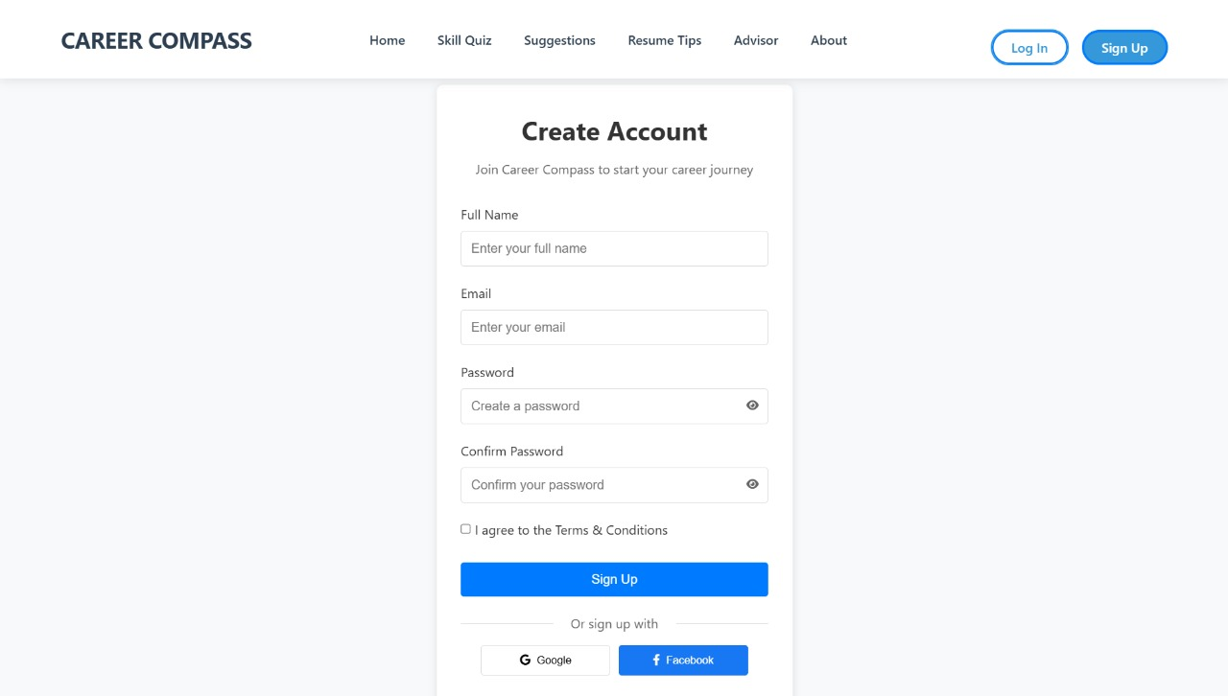

- Dashboard

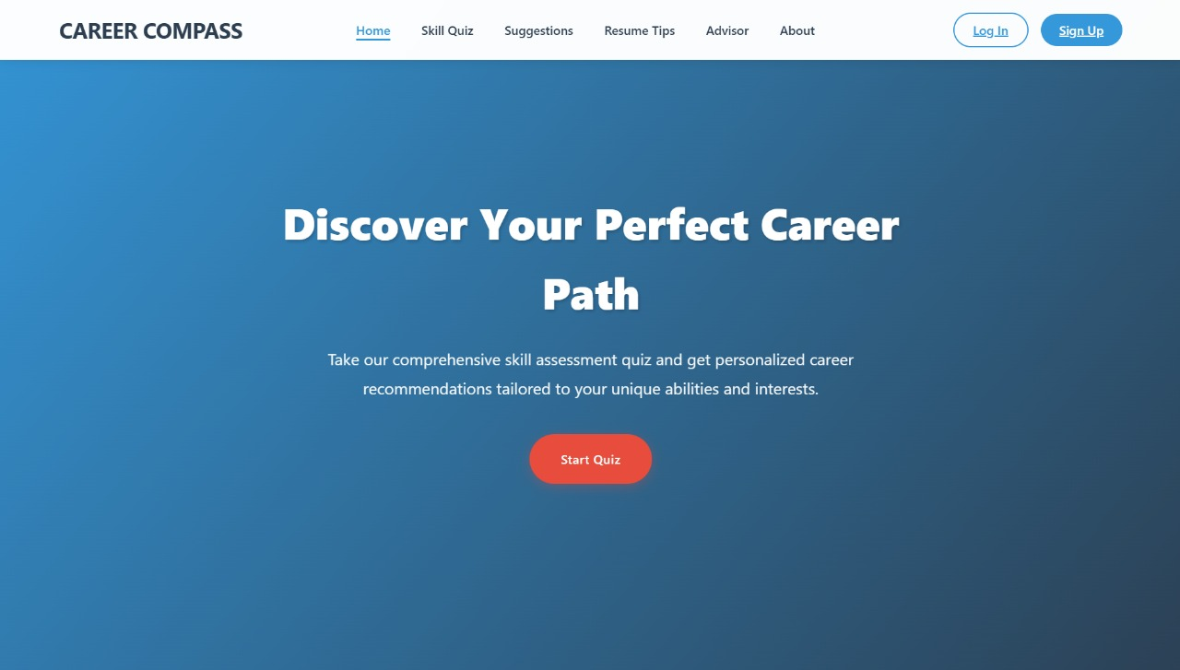

- AI Prompt Response Sample

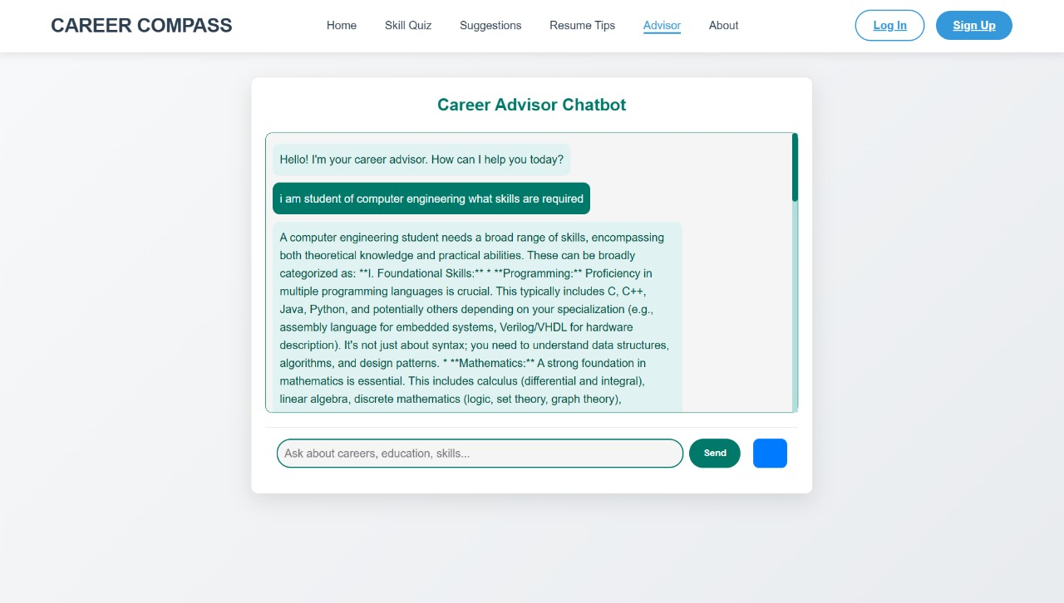

- Skills Assessment UI

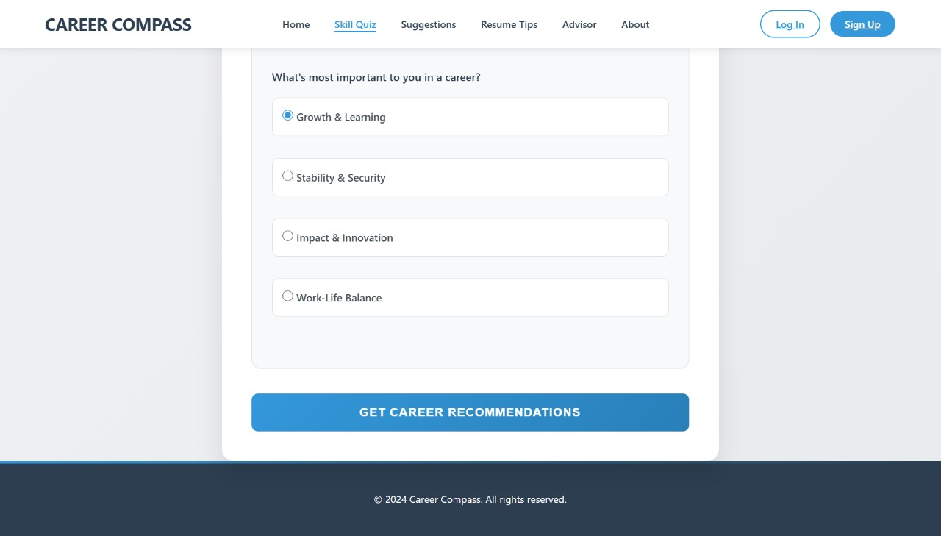

- Career Recommendation Output

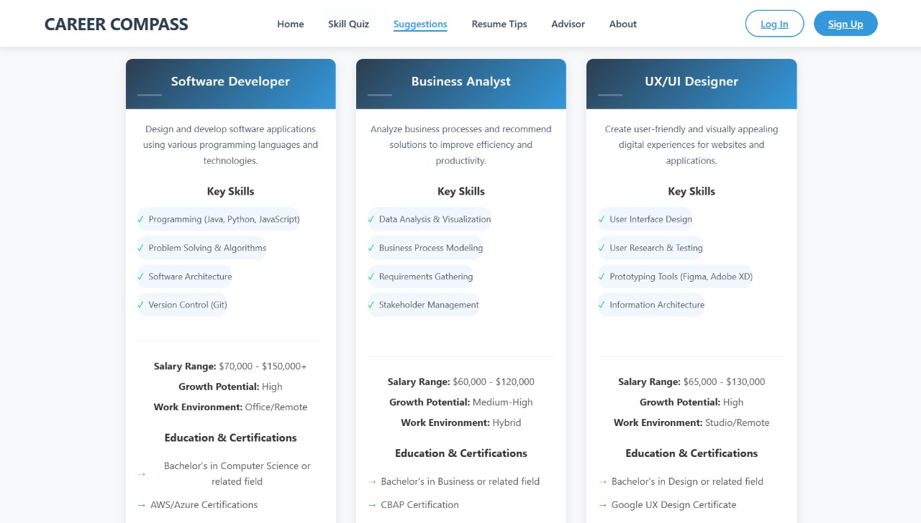

Challenges & Solutions
- Secure Auth – Firebase Authentication
- Data Storage – Firestore DB
- Dynamic Responses – Gemini 2.0 Flash API
- UI Design – Bootstrap / CSS3
- Personalization – Prompt-tuned AI outputs

Future Scope
- Chatbot-based 24/7 virtual assistant
- LinkedIn integration for live network insights
- Gamified skill tracking dashboard
- Mobile App Version
- AI Resume Analyzer with file upload

Conclusion
- A smart, AI-powered platform for career guidance
- Combines modern tech (AI + Firebase) with user-friendly UI
- Helps users make informed, strategic career choices
- Ready to scale with real-time, personalized features
Thank You for Your Time!

